

Compiler Construction Lab 8

Name: Kashaf Ahmad
Sap ID: 53155
Submitted To: Ma`am Hasnat Bibi

Task 1:
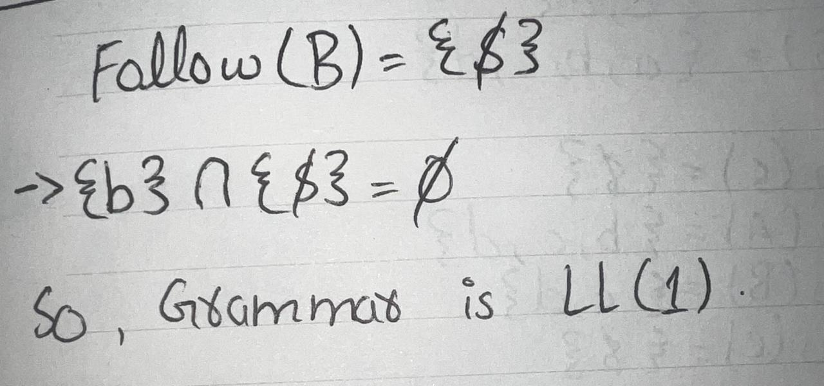
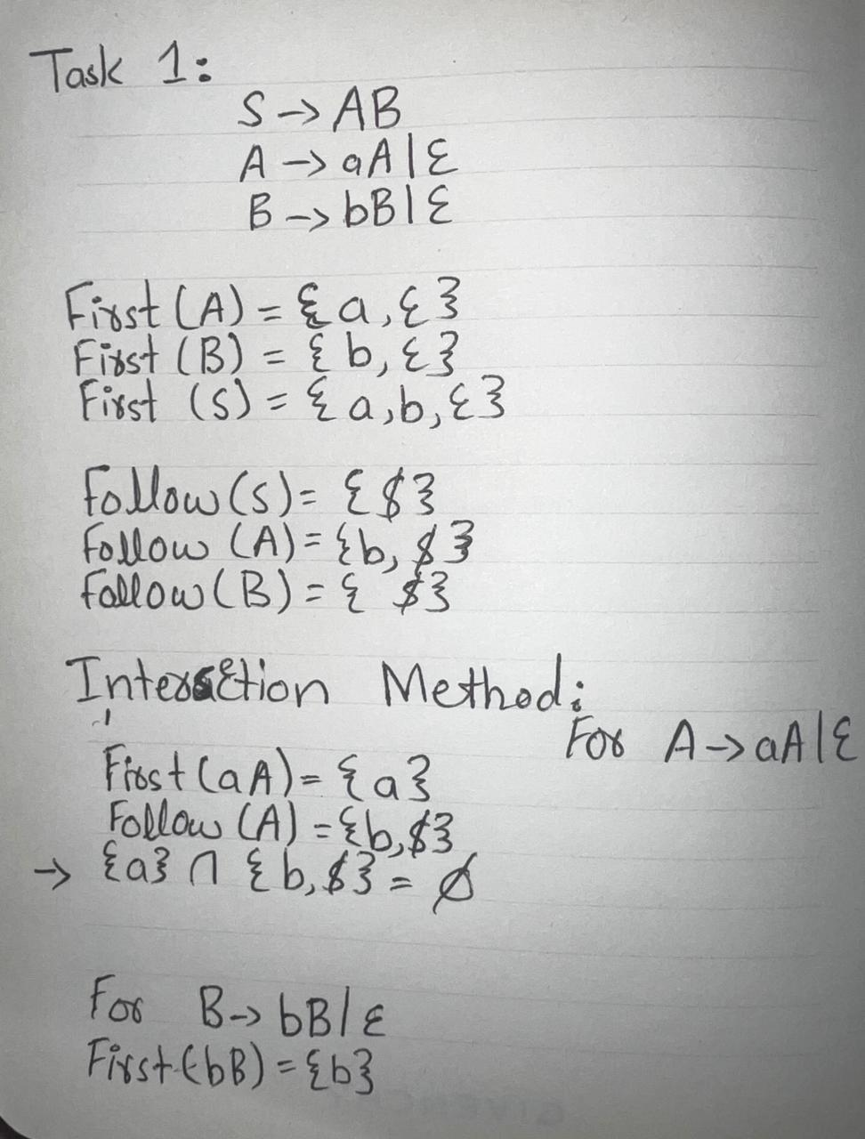

Task 2:
For grammar:
E → T E'
E' → + T E' | ε
T → F T'
T' → * F T' | ε
F → id | (E)

Perform:
- Parse the string:
id + id * id

Table:
Stack | Input | Action
$E | i+i*i$ | E → T E'
$E'T | i+i*i$ | T → F T'
$E'T'F | i+i*i$ | F → i
$E'T'i | i+i*i$ | Match i
$E'T' | +i*i$ | T' → ε
$E' | +i*i$ | E' → + T E'
$E'T+ | +i*i$ | Match +
$E'T | i*i$ | T → F T'
$E'T'F | i*i$ | F → i
$E'T'i | i*i$ | Match i
$E'T' | *i$ | T' → * F T'
$E'T'F* | *i$ | Match *
$E'T'F | i$ | F → i
$E'T'i | i$ | Match i
$E'T' | $ | T' → ε
$E' | $ | E' → ε
$ | $ | Accept

Task 3:
#include <iostream>
using namespace std;

string input;
int i = 0;

void S() {
if(input[i] == 'a') {
i++; // match a
S(); // recursive
if(input[i] == 'b')
i++; // match b
else {
cout << "Rejected\n";
exit(0);
}
}
}
int main() {
cout << "Enter string: ";
cin >> input;
S();
if(input[i] == '\0')
cout << "Accepted\n";
else
cout << "Rejected\n";
}
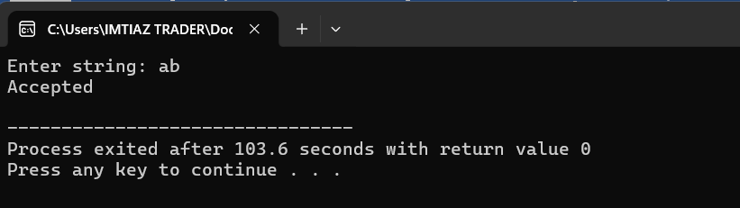

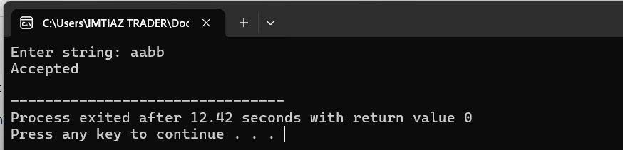

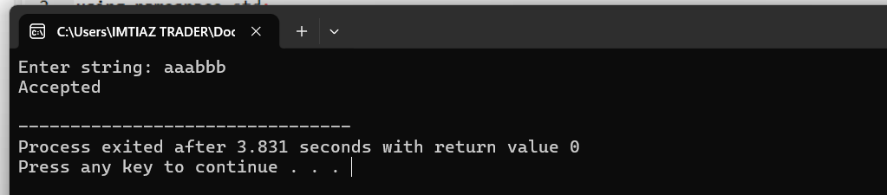

- Ab

Steps:
- Start with S
- First symbol = a → use rule S → aSb
Now expecting:
a S b
- Match a
Remaining input: b
- Now go inside S
  - Next symbol is b, not a
  - So use S → ε
- Now match b
- Input finished
Accepted

- aabb

Steps:
- Start S
- See a → use:
- S → aSb
- Match first a
Remaining: abb

Now inside S:
- Again see a → use:
- S → aSb
- Match second a
Remaining: bb
Now inside S again:
- Next symbol = b → use:
- S → ε

Now matching b’s:
- Match first b
Remaining: b
- Return to previous level → match second b
- Input finished
Accepted

- aaabbb

Steps:
- S → aSb
Match a → remaining aabbb
- S → aSb
Match a → remaining abbb
- S → aSb
Match a → remaining bbb
- Next is b → use:
- S → ε
Now matching b’s (returning back):
- Match b → remaining bb
- Match b → remaining b
- Match b → remaining empty
- Input finished
Accepted

